Trinity’s Mission Statement
Uniting us in the worship of the Triune God, Christ gives us our mission:
Proclaim the Gospel in order to make disciples throughout the
world and to nurture them for lives of service.

Calendar of Events

Sunday, February 11: Worship – 8 & 10:30 am
Sunday School and Bible Classes – 9:15 am
Children’s Choir (Grades 5-6) Sings – 8 am
Baptism Affirmation – 10:30 am
Senior Choir Sings – 10:30 am

Monday, February 12: Bible Class – 7 am
Elders’ Meeting – 6 pm
Board Meetings – 7pm

Tuesday, February 13: TSL Confirmation – 8 am
Senior Choir Practice – 7 pm

Wednesday, February 14: TSL Confirmation – 8 am
Lenten Worship with Communion – 3:30 & 7 pm
Lenten Supper – 4:30-6:30 pm

Thursday, February 15: TSL Confirmation – 8 am
Bible Class – 10:30 am

Sunday, February 18: Worship with Communion – 8 & 10:30 am
Sunday School and Bible Classes – 9:15 am
Annual Meeting – 11:45 am

Church Attendance

Wednesday, January 31
43
Sunday, February 4
205

SCRIPTURE READINGS FOR SUNDAY, FEBRUARY 18
Genesis 22:1-18
Romans 8:31-39
Mark 1:12-15

Schools we support with our prayers and offerings

Lakeside Lutheran High School (grades 9-12)
231 Woodland Beach Road – Lake Mills - 53551
www.llhs.org
Principal James Grasby

Luther Preparatory School (grades 9-12)
1300 Western Avenue – Watertown - 53094
www.lps.wels.net
President Matt Crass

Trinity-St. Luke’s School
Principal James Moeller
Mr. Gregg Birkholz, Mr. Jared Matthies, Mrs. Cheryl Holzhueter, Mrs. Michelle Wegner & Mrs. Peggy Uttech
801 S 5th Street – 920-261-3615
303 Clark Street – 920-206-1844
www.fastdir.com/tsl

Bible Classes & Bible Activity Hour
Between Sunday Service from 9:15-10:15 am
Most Sunday morning classes can be found on the lower level.
An elevator is located by the 5th Street entrance

 |  | Sunday, February 11 | Sunday, February 18
Adult | Fellowship Hall - West | 95 Theses  For the 21st Century | 95 Theses  for the 21st Century
Teens | Teen Room | Judges | Judges
Gr.1 – Gr. 6 | Fellowship Hall - East | Jesus Appears in Glory | Jesus Rides into Jerusalem
2yr. old - K | Sunday School Room | Jesus Calms the Storm | Jesus Walks on Water

Monday Morning Bible Class – 7 am
Topic: Luther’s Small Catechism
Thursday Bible Class – 10:30 am
Topic: Mark

Church Attendance

SERVING JESUS AT WORSHIP

WORSHIP LEADER: Pastor Dustin Yahnke
PREACHER: Pastor Brett Bauer
ORGANIST: Mrs. Bethel Zabell
CHILDREN’S CHOIR DIRECTOR: Mrs. Cheryl Holzhueter
CHILDREN’S CHOIR ACCOMPANIST: Mr. Joshua VonDeylen
SENIOR CHOIR DIRECTOR: Prof. Naomi Fritz
SENIOR CHOIR ACCOMPANIST: Mrs. Linda Moeller

SUNDAY, FEB 11: (8a) Dave Zastrow and Eric Zastrow (10:30a) Jim Schwartz
WEDNESDAY, FEB 14: (3:30p) Jack Nass, James Jerabek, Earl Roberts (7:00p) Jim Schwartz
SUNDAY, FEB 18: (8a) Mike Craig and Steve Pett (10:30a) Pete Nass and Mark Zastrow

COMMUNION ASSISTANTS WEDNESDAY, FEB 14: (3:30p) Dale Zastrow (7:00p) Steve Pett

GREETERS FOR SUNDAY, FEB 11: (8a) Sharon Zastrow, Kim Schwartz, Dave and Leni Kahler, Russ and Ann Marcks (10:30a) Debbie Ebert, Barb McAleer, Mike Duehring, Jenny Frank
SUNDAY, FEB 18: (8a) Birdie Duin, Mona Pett, Amy Maurice, Herb and Ione Staude (10:30a) Janelle Loescher, Gary and Carole Muir, Bill and Joyce Nass, Clarice Schmidt

COUNTERS FOR SUNDAY, FEB 11: Matt and Theresa Asmus, Troy Thede
SUNDAY, FEB 18: Ann Schultz, Jim and Mary-Anne Schwartz

VIDEOGRAPHERS FOR SUNDAY, FEB 11: (8a) Bob Turney (10:30a) Bob Turney
SUNDAY, FEB 18: (8a) Dennis Whiting (10:30a) John Boehringer

BULLETIN COMMITTEE FOR FRIDAY, FEB 16: Kim Turney

MORNING TREATS SUNDAY, FEB 11: Bulletin Committee (Kim Turney)
SUNDAY, FEB 18: Decorating Committee (Sharon Zastrow)

LENTEN SUPPER WEDNESDAY, FEB 14: Church Council

ALTAR COMMITTEE FOR FEBRUARY: Becky Knauth, Birdie Duin
FLOWER COMMITTEE FOR FEBRUARY: Sandy Braun, Becky Knauth

Prayer Partners Prayer Requests – Contact Pastor Brauer or Pastor Yahnke
Visitors – Please sign our guest register found in the Narthex
Available from the Ushers
Large print materials
Personal listening devices
Children’s Bulletins and Quiet Bags
Available online – www.trinitywatertown.net
- Bulletins, Sermons, Daily Bible Readings
- Updated calendar, Newsletters
- Electronic donation forms

Sunday, February 11, 2018

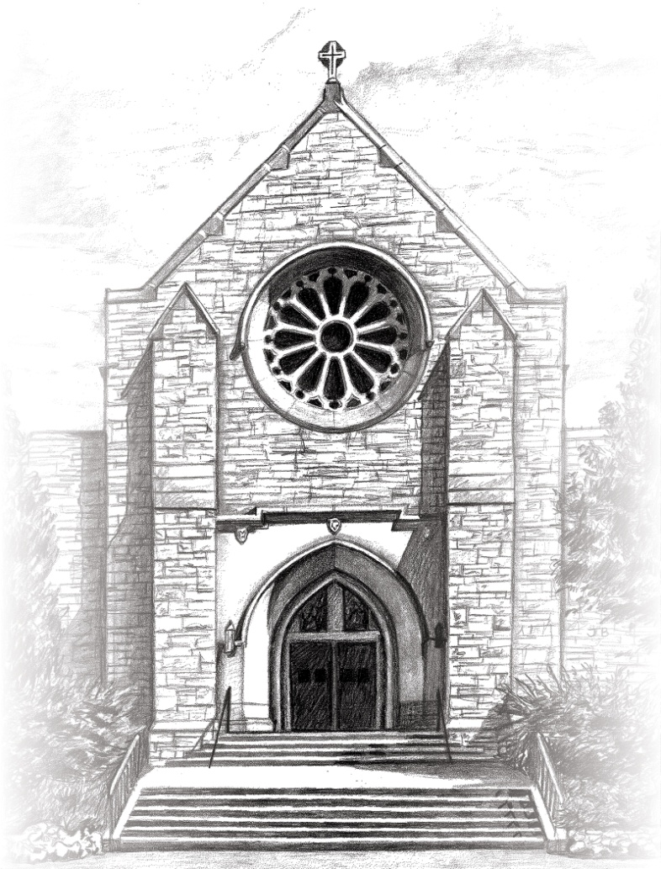

604 South Fifth Street, Watertown, Wisconsin 53094
920-261-3511

Pastor Brett Brauer Pastor Dustin Yahnke
Cell: 920-915-9070 Cell: 414-614-0077
trinitypastor@charter.net pastoryahnke@hotmail.com

Our Ministry at Trinity

Baptism Affirmation
- The Lord blessed Brandon and Tina Nissen with a baby boy, Oakley, who was born on January 19 and baptized at the hospital on January 20. Today we publicly affirm that private baptism in the 10:30 service. Sons are a heritage from the Lord, children a reward from him (Psalm 127:3).

Asleep in Jesus
- Liane Porzky entered eternal glory with Christ on Thursday, February 1. A Christian funeral will be held yesterday, February 10 at Schmutzler-Vick Funeral Home. Blessed are the dead who die in the Lord (Revelation 14:13).

Midweek Lenten Worship
- Lent begins this year with Ash Wednesday on February 14. We will mark Ash Wednesday as a stand-alone festival with the Lord’s Supper. The five following Wednesdays will have the theme “Behold the Lamb of God.” The sermons will be based on the Passion History.

Lenten Suppers
- Lent begins with Ash Wednesday, February 14. The Trinity Church Council will prepare and serve chili. We intend to offer suppers between services on each of the Wednesdays. If any Trinity group wishes to prepare and host a meal, please contact the church office (261-3511) or John Braun (261-2750).

Grief Support Group
- Several years ago Trinity had a group for widows and widowers to encourage and support each other with God’s Word and our Christian fellowship. Upon the request of some members, we will start up this group again. The target date to begin is Tuesday, February 20 at 7 pm (meeting at church). Members whose spouse or other loved one has entered eternal life with Christ are invited to come.

Pioneer News: Serve with LOVE on Valentine’s Day!
- Pioneers are serving their Lord (and dinner) on Ash Wednesday, February 14, at St. Luke's between 4:30-6:30 pm. Parents, we really need your help for that night, with bringing both your child(ren) to serve but also supplying extra veggies and desserts. Please bring both veggies and dessert (if possible) that night to the church kitchen before the 4 pm service. Wanda and I shall get them ready during the service to be served by the children. Thank you!

Annual Voters’ Meeting – Sunday, February 18
- We will hold the annual meeting on Sunday, February 18 following the second service. All members are invited to attend to stay informed about our ministry as a Christian congregation.

2018 Greeters’ and Ushers’ Schedules
- These schedules are now available. You may find your copy on the ushers’ table in the narthex. Thank you for your service to Christ and to Trinity!

Forward in Christ
- The February issue of Forward in Christ is available to subscribers in the Fireside Room. A library copy is available on the bookshelf in the Fireside Room.

Valentine Cards
- A limited collection of Christian Valentine’s Day cards are available in the Fireside Room for $.50 each.

Thank You
- I would like to thank everyone for the warm welcome and words of encouragement in my start as secretary. I am truly blessed to be able to work in an atmosphere where Christ’s love is so evident. Please be patient as I continue to learn the numerous tasks involved with this position. Thank you again. In Christ service, Ellen Bohn

TSL and the WPCP
- The enrollment period for families who wish to participate in the Wisconsin Parental Choice Program (WPCP) opens February 1 and continues through April 20. Parents of TSL students currently in 4K and 5K (next school year's 5K and first grade students) as well as students who this year are attending public school in 4K through grade 7, are home-schooled, or did not attend school can submit applications. Information on the WPCP program as well as aids to assist in completing the application form can be found at dpi.wi.gov/choice. You can also contact Mr. Moeller at 261-3615 or via email at jmoeller@tslwels.org with any questions you might have.

TSL ECE Registration and Open House
- Planning has started for this year's ECE Registration and Open House which will be held on Thursday, March 1. This is an opportunity for prospective families to meet the teachers and staff of our 3K, 4K, 5K, and grade 1 programs and see the classrooms. Activities for the students will also be held. More detailed information will be sent out via surface mail within the next few weeks to families who are on the congregations' membership lists. Please share this information with family and friends.

Twice Is Nice “Stuff the Truck”
- February 17 is the Saturday of the elementary basketball tournament at Lakeside Lutheran High School. Anyone who will be visiting campus for the tourney (or who could be in the area) is encouraged to bring household donations, including furniture, to the big truck in the corner of the LLHS east parking lot from 10 am - 4 pm. Teens will unload your vehicle, pack the truck and get it all down to Jefferson that day. Donation receipts will be available. Thanks for your generosity as we help keep Twice Is Nice supplied with donations this time of year! If you have any questions about what is accepted, feel free to call the store at 920-674-6868 and ask for a day manager from 9-5 Monday-Saturday.

Job Opportunity
- St. John's Lutheran childcare in Jefferson is looking to hire a Christian assistant teacher in the 0-1 year old infant classroom and a Christian assistant teacher in the 1-2 year-old toddler classroom. These full time positions are available immediately. Please contact us at childcare@sjlwels.org or 920-674-4964 to inquire about the childcare positions.

Camp Phillip
- Brochures for Camp Phillip Summer 2018 are available in the brochure rack by the bulletin board. Programs include camps for grades K-8, teens, families, women, grandparents/grandchildren and Jesus Cares. More information can be found at www.campphillip.com.

